**Develop a menu-driven application that demonstrates the implementation of Keyboard driven and mouse driven actions in Selenium**

**Code: -**

|  |
| --- |
| import java.time.Duration;  import org.openqa.selenium.By;  import org.openqa.selenium.Keys;  import org.openqa.selenium.WebDriver;  import org.openqa.selenium.WebElement;  import org.openqa.selenium.chrome.ChromeDriver;  import org.openqa.selenium.interactions.Actions;  public class Mouse_Keyboard {  public static void main(String[] args) throws InterruptedException {  // TODO Auto-generated method stub  WebDriver driver=null;  driver=new ChromeDriver();  driver.manage().window().maximize();  driver.manage().timeouts().implicitlyWait(Duration.ofSeconds(10));    //https://demo.automationtesting.in/Register.html -- for practice  driver.get("https://www.saucedemo.com/v1/");  driver.findElement(By.id("user-name")).sendKeys("standard_user");  driver.findElement(By.id("password")).sendKeys("secret_sauce");  driver.findElement(By.id("login-button")).click();  WebElement wl=driver.findElement(By.id("item_3_title_link"));  Actions actionobj1 = new Actions(driver);    // Perform Click Action on the Web Element normal click , right click double click  // actionobj1.click(wl).build().perform(); // normal click  // Duration time =actionobj1.contextClick(wl).getActionDuration(); // right click  // System.out.println("Time taken to perform the action " + time);  // actionobj1.doubleClick(wl).build().perform(); // Double click  //  /*driver.navigate().to("https://demoqa.com/buttons"); //Navigating to another page  WebElement wlD=driver.findElement(By.id("doubleClickBtn"));  Actions actionobj = new Actions(driver);  actionobj.doubleClick(wlD).build().perform();  WebElement wlR=driver.findElement(By.id("rightClickBtn"));  actionobj.contextClick(wlR).build().perform(); */    // Perform Mouse Hover Action on the Web Element  /* driver.navigate().to("https://demoqa.com/links");  Actions actionobjmh = new Actions(driver);  WebElement wlmh=driver.findElement(By.linkText("Home"));  actionobjmh.moveToElement(wlmh).build().perform();  System.out.println("Mouse hover Action performed"); */  // Perform drag & Drop operation on a webelement  /* driver.get("https://demo.automationtesting.in/Static.html");  // Create an instance of the Actions class  Actions action = new Actions(driver);  // Locate web source element that is a image  WebElement source= driver.findElement(By.id("mongo"));  // Locate target web element that is a box  WebElement target= driver.findElement(By.id("droparea"));  //perform the drag and drop action drag image and put in a box  action.dragAndDrop(source, target).build().perform(); */    // Perfrom click hold and release operation  /*driver.get("https://demo.automationtesting.in/Static.html");  // Create an instance of the Actions class  Actions action1 = new Actions(driver);  // Locate web source element that is a image  WebElement source1 = driver.findElement(By.id("angular"));  // Locate target web element that is a box  WebElement target1 = driver.findElement(By.id("droparea"));  // click a image hold it and move to box and realse the image in box  action1.clickAndHold(source1).moveToElement(target1).release().build().perform(); */    // keyboard key press up and down -> shift ,control, delete, backspace  /*driver.get("https://demoqa.com/automation-practice-form");  Actions action = new Actions(driver);  WebElement id = driver.findElement(By.id("firstName"));  action.keyDown(Keys.SHIFT).perform();  id.sendKeys("Inshirah");  System.out.println("name Entered");  Thread.sleep(1000);  action.keyUp(Keys.SHIFT).perform();  action.keyDown(Keys.CONTROL).sendKeys("a").keyUp(Keys.CONTROL).sendKeys(Keys.BACK_SPACE).perform(); */    // Upload any file to the server  String baseUrl = "https://demo.guru99.com/test/upload/";  driver.get(baseUrl);  WebElement uploadElement = driver.findElement(By.id("uploadfile_0"));  // enter the file path onto the file-selection input field  uploadElement.sendKeys("E:\\Users\\mca23_001\\Documents\\sample.jpg");  // check the "I accept the terms of service" check box  driver.findElement(By.id("terms")).click();  // click the "UploadFile" button  driver.findElement(By.name("send")).click();  System.out.println("File Uploaded Sucessfully");  }  } |

**OUTPUT: -**

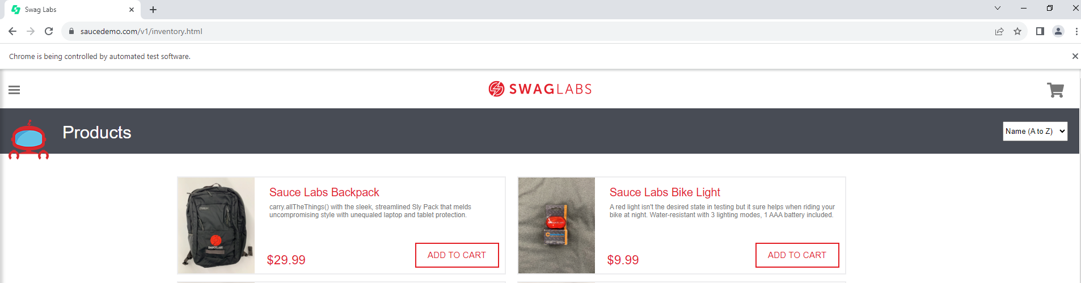

**Normal Click**

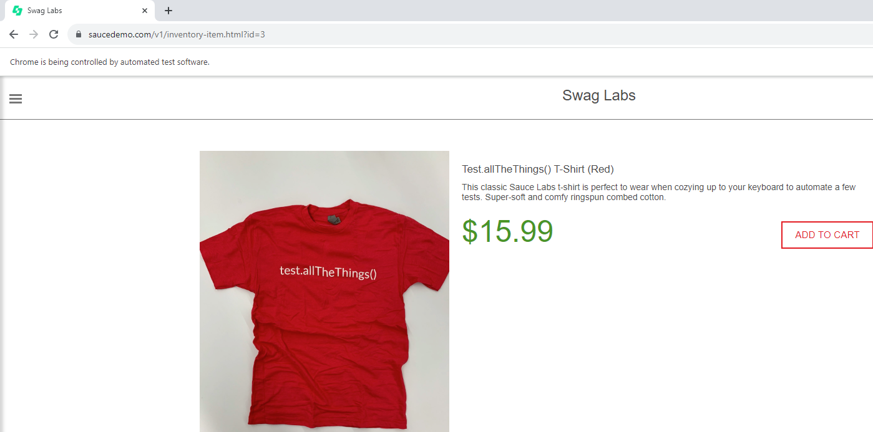

**Right Click**

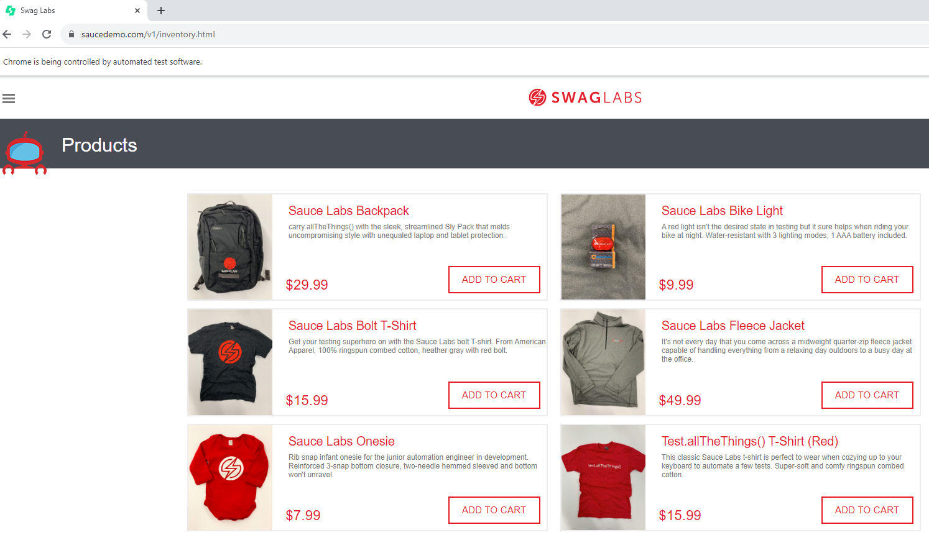

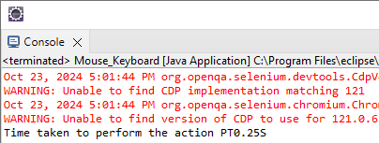

**Double Click**

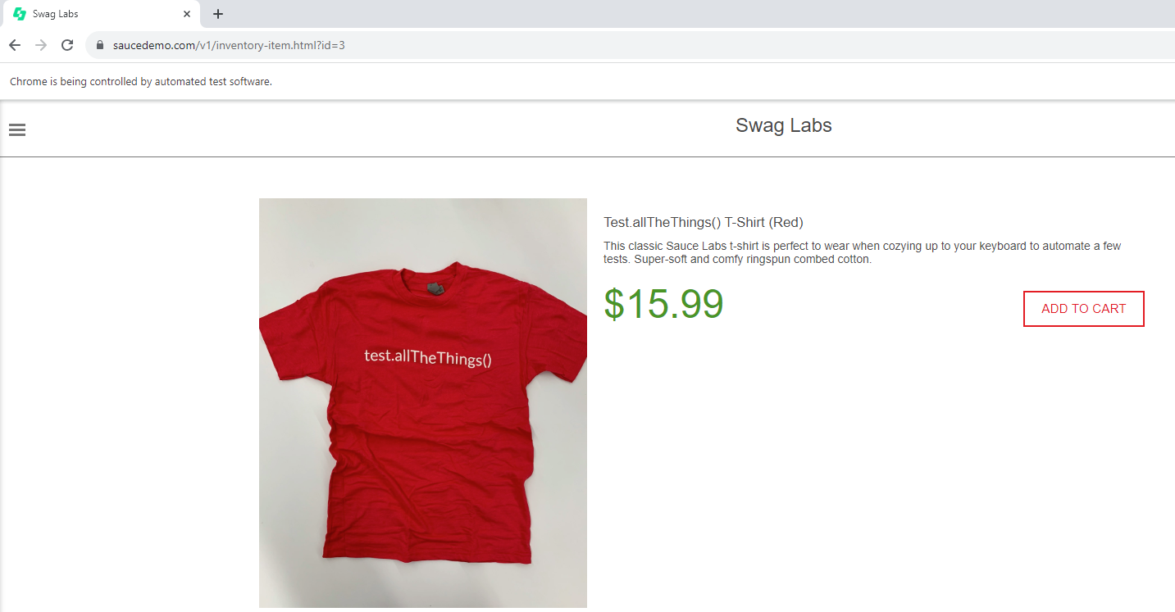

**Navigating to another page and performing click**

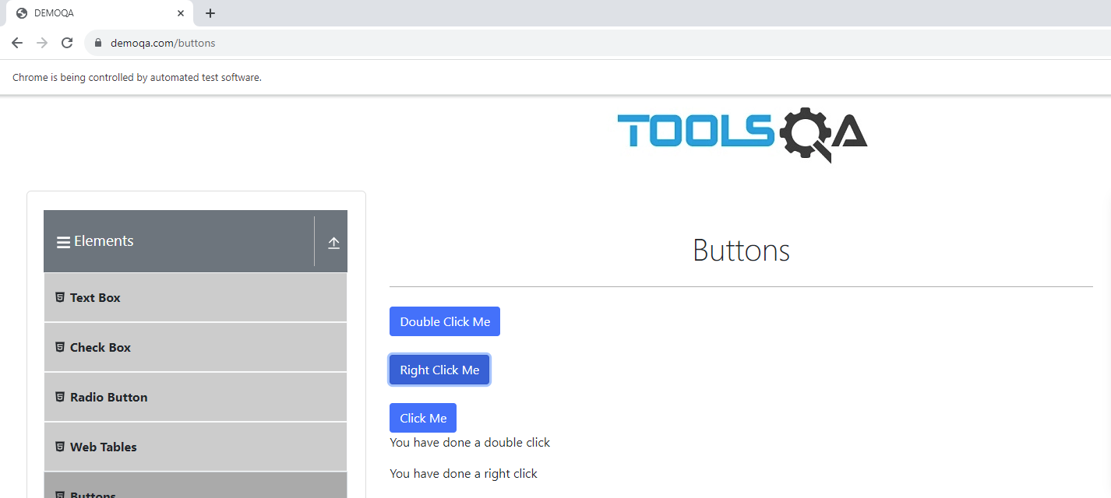

**Mouse Hover**

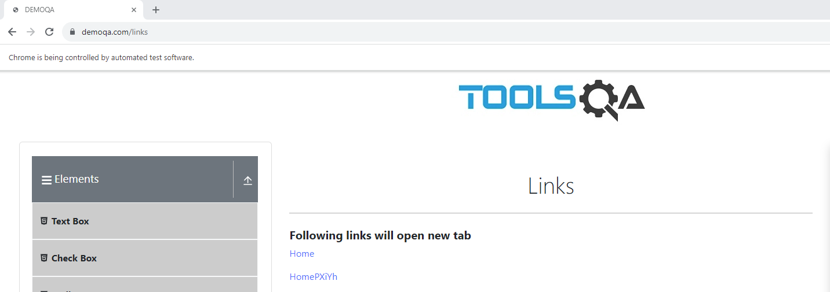

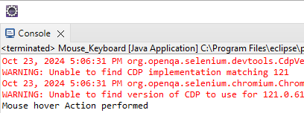

**Drag & Drop operation**

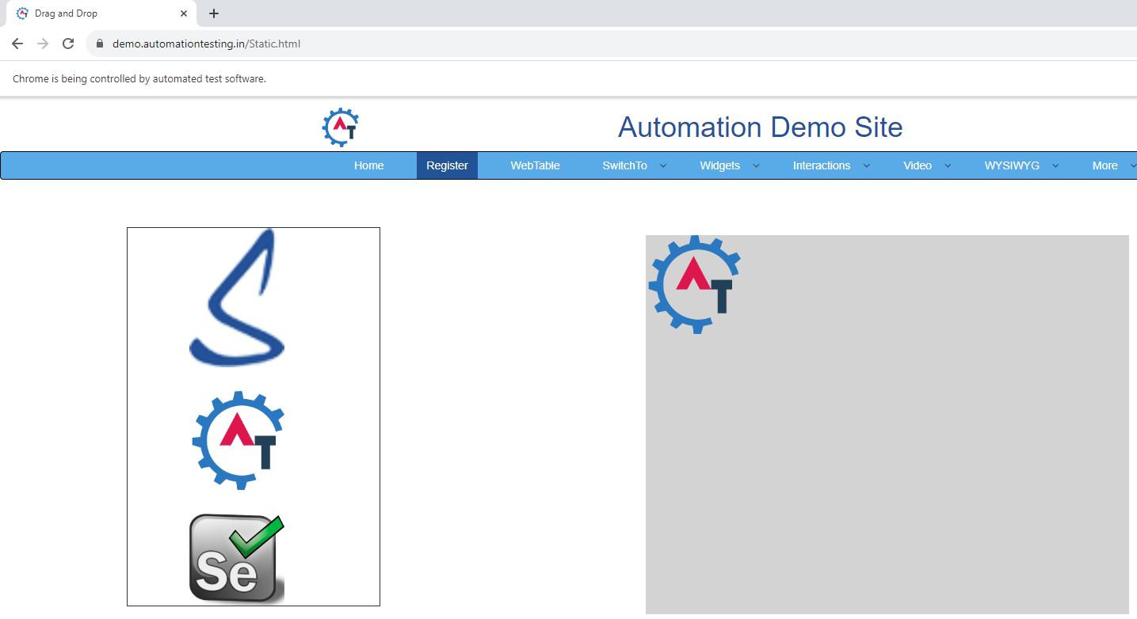

**Click hold and release operation**

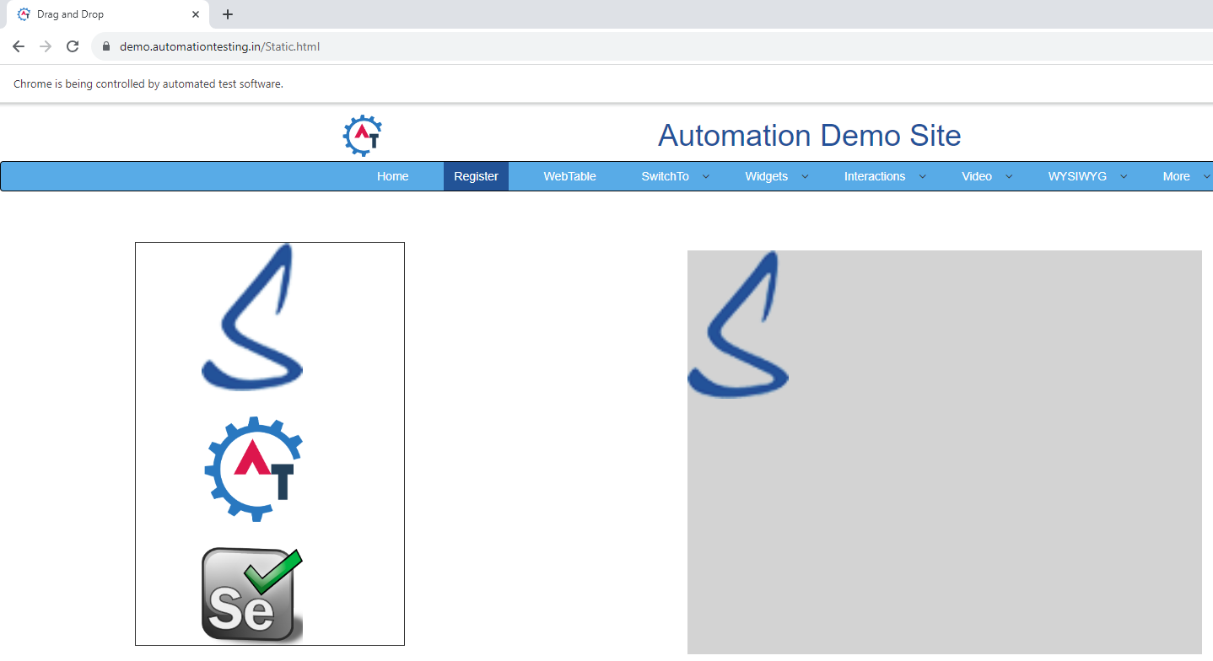

**keyboard key press up and down -> shift ,control, delete, backspace**

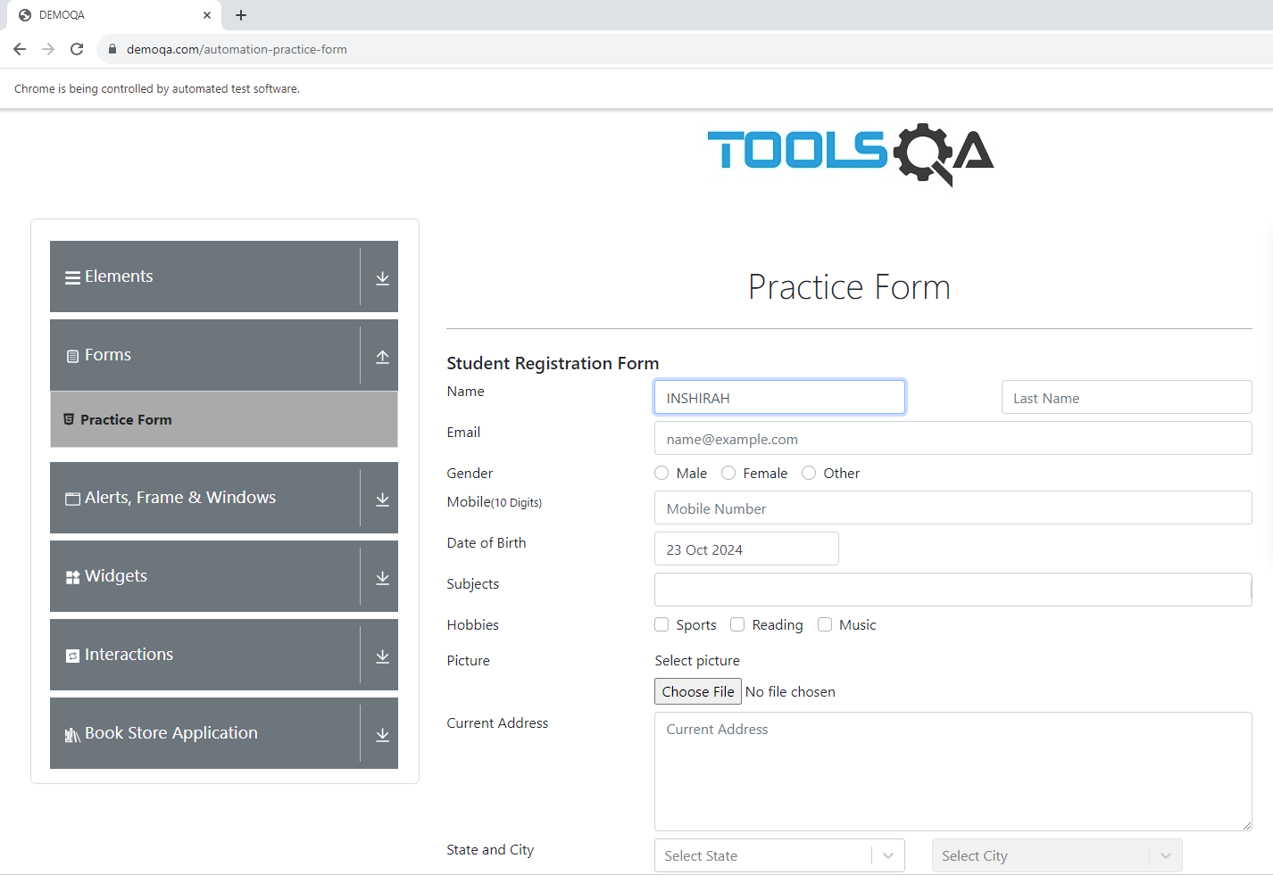

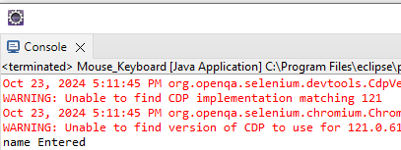

**Image**

